WEIGHT AND MASS
- DEFINITIONS
  - Mass- __________________________________________ an _____________________ has.
  - Matter- something that _____________________ and ______________________________________.
  - Weight- is the _____________________ of an object, it is _____________________ upon _____________________.
- Units for Measuring Mass
  - Mass is _____________________ in _____________________ and _____________________.
    - 1 paper clip= 1 _____________________
    - _____________________ =1 kilogram
    - The average _____________________ adult weighs _____________________
  - Tools for Measuring Mass
    - The _____________________ _____________________ is the tool we use _____________________ mass.

- COMPARE AND CONTRAST
  - MASS vs. WEIGHT
  - Always remains _____________________ Depends on _____________________

  - Does _____________________ on gravity weight=_____________________ x gravity

  - weight of an object ___________ if the gravity changes

Classification
- Species of Organisms
  - There are _____________________ known species of organisms
  - This is only 5% of all organisms that _____________________!!!!!
  - New organisms are still _____________________
- What is Classification?
  - Classification is the _____________________of organisms into _____________________based on their _____________________
  - Classification is also known as _____________________
  - Taxonomists are _____________________ that identify & name _____________________
- Benefits of Classifying
  - Accurately & _____________________ names organisms
  - Prevents _____________________ such as starfish & jellyfish that ____________________ fish
  - Uses same _____________________ (Latin or some Greek) for all names
    - Confusion in Using Different Languages for Names
    - 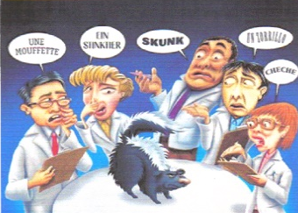
    - Latin Names are Understood by all
    - 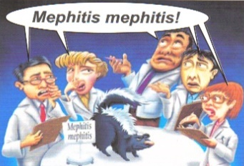

- Early Taxonomists
  - 2000 years ago, _____________________ was the first _____________________
    - Aristotle _____________________ organisms into _____________________
    - He subdivided them by their _____________________---land, sea, or air dwellers
  - John Ray, a botanist, was the first to use _____________________ for naming
    - His names were very long _____________________ telling _____________________ about the plant
- Carolus Linnaeus 1707 – 1778
  - 18th century _____________________
  - Classified organisms by their _____________________
  - Developed _____________________still used today
  - Called the “_____________________ of Taxonomy”
  - Developed the modern system of naming known as __________________________________________
  - Two-word name (_____________________ & _____________________)
- Standardized Naming
  - used
  - Genus species
  - Latin or Greek
  - _____________________ in print
  - Capitalize _____________________, but NOT _____________________
  - _____________________ when writing
- Rules for Naming Organisms
  - _____________________Code for _____________________ _____________________ contains the rules for naming organisms
  - All names must be approved by _____________________ _____________________ Congresses (International Zoological Congress)
  - This prevents _____________________ names
- Classification Groups
  - Taxon (taxa-plural) is a _____________________ into which _____________________ organisms are placed
  - There is a _____________________ of groups (taxa) from _____________________ to most _____________________
  - Domain, _____________________, Phylum, _____________________, Order, Family, _____________________, species
- Hierarchy-Taxonomic Groups
  - Domain
  - Kingdom
  - Phylum (_____________________ – used for _____________________)
  - Class
  - ____________________Family
  - Genus
  - Species
  - 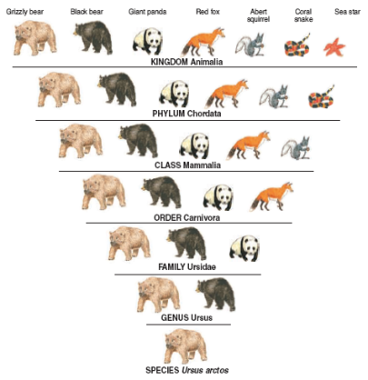
  - Dumb
    - King
      - Phillip
        - Came
          - Over
            - For
              - Gooseberry
                - Soup!
- 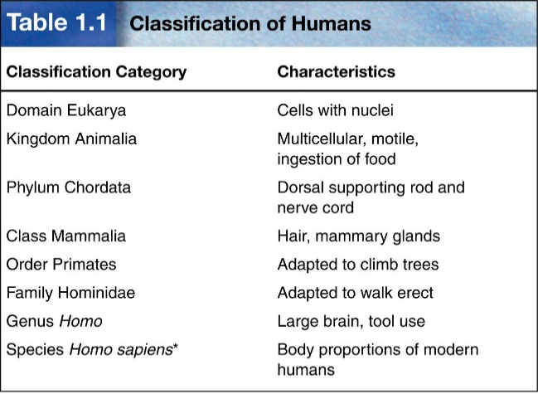
- Domains
  - _____________________, most inclusive taxon
  - _____________________ domains
  - _____________________ and _____________________ are _____________________ prokaryotes (no _____________________ or membrane-bound _____________________)
    - Archaea
      - ARCHAEBACTERIA
        - Probably the _____________________ to evolve
        - Live _____________________ environments
        - Found in:
          - _____________________ Treatment Plants (Methanogens)
          - _____________________ or Volcanic Vents (Thermophiles)
          - Hot Springs or _____________________ that are acid
          - _____________________ water (Dead Sea; Great Salt Lake) - Halophiles
    - Bacteria
      - EUBACTERIA
        - Some may cause _____________________
        - Found in _____________________ except _____________________ ones
        - Important _____________________ for environment
        - _____________________ important in making cottage _____________________, _____________________, buttermilk, etc.
  - Eukarya are more _____________________ and have a _____________________ and membrane-bound _____________________
    - Domain Eukarya _____________________into _____________________
- Kingdom
  - _____________________ (protozoans, algae…)
    - Most are _____________________
    - Some are _____________________
    - Some are _____________________, while others are _____________________
    - _____________________
  - _____________________ (mushrooms, yeasts …)
    - Multicellular, except _____________________
    - Absorptive _____________________ (digest food _____________________ their body & then absorb it)
    - Cell walls made of ____________________
  - _____________________ (multicellular plants)
    - _____________________
    - _____________________
    - Absorb _____________________ to make _____________________ – _____________________
    - Cell walls made of _____________________
  - Animalia (____________________animals)
    - Multicellular
    - ____________________ heterotrophs (consume ____________________& digest it ____________________their bodies)
    - Feed on plants or animals
- Basis for Modern Taxonomy
  - ____________________ structures (____________________,____________________)
  - Similar ____________________ development
  - Molecular Similarity in ____________________, or ____________________sequence of Proteins
  - 