TOPIC 1
Electromagnetic Spectrum
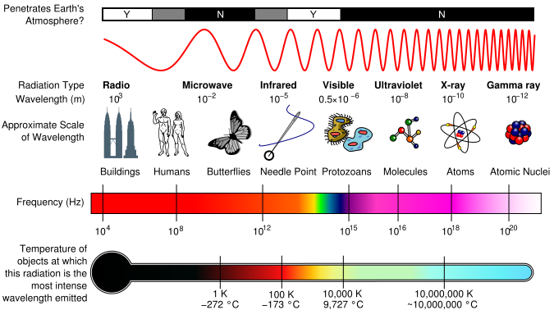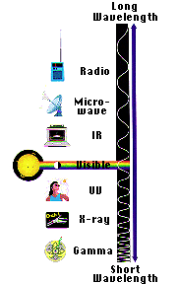
- Radio waves
  - have the in the electromagnetic spectrum.
  - These waves carry the you listen to on the radio.
  - They also carry signals to and phones.
- Microwaves
  - Have wavelengths than waves, which heat the food we eat.
  - They are also used for , like the radar used in weather forecasts.
- Infrared waves
  - with wavelengths and wavelengths.
  - Infrared waves with long wavelengths can be .
  - Heat Lamps give off these infrared waves.
  - We call these infrared or infrared waves.
  - The gives off infrared waves with wavelengths.
- Visible light waves
  - are the only electromagnetic waves .
  - We see these waves as the of the rainbow.
  - Each color has a wavelength.
  - Red has wavelength and violet has the wavelength.
  - These waves combine to make .
- Ultraviolet waves
  - have wavelengths than visible light waves.
  - These waves are to the human eye, but some can see them.
  - Of the sun's light, the ultraviolet waves are responsible for causing .
- X-Rays
  - As wavelengths get , the waves have more .
  - X-Rays have smaller wavelengths and therefore more energy than the waves.
  - X-Rays are so that they pass easily allowing doctors to look at our .

- Cosmic Rays/Gamma Rays
  - are high energy , originating in , that travel at nearly and strike the Earth from all .
  - Aurora Borealis: are associated with the , a flow of ions flowing outward from the Sun.
  - have the wavelength and energy of the waves in the electromagnetic spectrum.
  - These waves are generated by atoms and in explosions.
  - Gamma rays cells, but doctors can use gamma rays to kill cells.
TOPIC 2
SCIENCE AND THE SCIENTIFIC METHOD

- What is Science?
  - The goal of science is to investigate and understand the natural world, to explain events in the natural world, and to use those explanations to make useful predictions.
  - Science: ____________________________________________________________________
    - Science deals only with the natural world.
    - Scientists: _________________________________________________________
    - Scientists propose _______________ that can be ______________ by examining evidence.
    - Science is an organized way of using evidence to learn about the natural world.
  - How is science done?
    - Science begins with an __________________.
      - This is the process of about events or processes in a careful, orderly way.
    - ___________ is the information gathered from .
      - There are two types of data:
        - Quantitative data are ___________________________________________.
        - Qualitative data are ____________________________________________.
    - Hypothesis
      - A hypothesis is a ______________________________________________.
      - A hypothesis must be stated in a way that makes it “ ”. The hypothesis is just a to a question, and it must be thoroughly .
- Scientific Methods
  - The scientific method is: ______________________________________ ______ ____
      - B. The Steps to the Scientific Method
      - Step 1: / Asking a Question
        - A problem or a question must .
          - Examples:
            - How much water can a root hair absorb?
            - Why does a plant stem bend toward the light?
            - What effect does temperature have on heart rate?
      - Step 2: Form a
        - Hypothesis: A possible ___________________ explanation to the or problem.
        - It is simply a and has not yet been __________________________.
        - It must be stated in a way that is . A statement is considered “testable” if can be that either does or does not support it.
      - Step 3: Designing a Controlled Experiment
        - The factors in an experiment that can be changed are called ____________. Some example of variables would be: temperature, of light present, , of solutions used.
        - A controlled experiment works with __________________________. If several variables were at the same time; the scientist would know which variable was for the observed results.
        - In a ________________________ only one variable is at a time. All other variables should be or “controlled”.
        - An experiment is based on the comparison between a ____________ with an ____________________.
          - These two groups except for one factor.
          - The group serves as the . It is the same as the group, except that the one that is being tested is .
          - The experimental group shows the that is being tested.
        - There are two variables in an experiment:
          - The independent variable is the variable that is ___________________________________________________
          - The dependent variable is the one
          - The dependent variable is the during the experiment. This data is collected as a the independent variable.
      - Step 4: Recording and Analyzing Results
        - The data that has been collected must be and to determine whether the data are .
      - Step 5: Drawing Conclusions
        - The evidence from the experiment is used to determine if the hypothesis is _____________________ _.
        - Experiments must be over and . When repeated, the results the same before a valid can be reached.

- Forming a Theory
  - A theory may be formed has been tested and is supported by .
  - Theory: A broad and comprehensive of what is to be true.
    - It is by considerable .

TOPIC 3
WAVES AND WAVE PROPERTIES
- Why are we able to see?
  - _________________________________________
- And…what is light?
  - _________________________________________
- So…what is a wave?
  - A wave is a disturbance that carries from to .
  - A wave ____________________ carry matter with it! It just ____________________ the matter as it goes through it.
    - Some waves do not need ____________________ (called a “____________________”) to be able to (for example, through space).
      - These are called ____________________ (or EM waves).
    - Some waves ____________________ have a ____________________ in order to move. These are called ____________________ waves.
- Wave Types
  - ____________________ waves: Waves in which the ____________________ moves at ____________________ angles to the ____________________ of the wave
    - Parts of transverse waves:
      - Crest: ________________________________________of the wave
      - Trough: ________________________________________of the wave
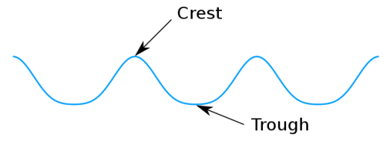
  - ____________________ (or ____________________) waves: Waves in which the ____________________back and forth in the ____________________direction as the wave
    - Parts of ____________________ waves:
      - Compression: where the are together.
      - Rarefaction: where the are

- Wave Properties
  - Wave ____________________ depend on what (____________________) is making the waves.
    - Wavelength: The ____________________between ____________________on a wave and the exact ____________________ on the ____________________wave.
    - Frequency: How many ____________________ go past a ____________________ in one ____________________; unit of measurement is ____________________.
      - The higher the ____________________, the ____________________in the wave.
        - 10 waves going past in 1 second = ____________________
        - 1,000 waves go past in 1 second = ____________________
        - 1 million waves going past = ____________________
    - Amplitude: How far ____________________moves from ____________________ position (where it is when ____________________ moving).
      - Remember that for transverse waves, the ____________________ point is the crest, and the ____________________ point is the trough.
      - Remember that for ____________________waves, the ____________________ where the medium is ____________________ together are called ____________________ and the ____________________where the medium is ____________________ apart are called ____________________.
    - The ____________________ together and ____________________ apart the ____________________ are, the ____________________the amplitude.
  - The ____________________ of a wave is ____________________ to the ____________________ of its amplitude.
    - Mathematically speaking
      - ____________________
      - Where:
        - E = ____________________ (the capacity to do work)
        - C = a ____________________ (depends on the medium)
        - A = ____________________
      - For example:
        - If ____________________is equal to 3 units (and we assume C = 1 for this case)
      - ________________________________________
      - Note that when the ____________________ of a ____________________ is one
  - Wave speed: ____________________the ____________________ in which the ____________________is traveling. It varies in ____________________, ____________________ and gases.
    - A ____________________ way to calculate speed:
      - ____________________= ____________________ x ____________________
        - OR
      - v = f x ג
- Changing Wave Direction
  - Reflection: ____________________________________________________________.
    - If the surface is ____________________, the ____________________ at which the wave hits ____________________will be ____________________as the angle at which it ____________________ the ____________________ (angle in = angle out).
    - This is the ________________________________________.
  - Refraction: ________________________________________.
    - This happens when a ____________________a new ____________________ and its ____________________ CHANGES.
    - The amount of ____________________ depends on the ____________________ it is ____________________.
  - Diffraction: ____________________________________________________________.
    - The amount of ____________________ depends on the ____________________of the obstacle and the size of the ____________________.
      - ____________________obstacle, ____________________wavelength = ____________________diffraction
      - ____________________obstacle, ____________________ wavelength =____________________diffraction

